CREDIT CARD DEFAULT PREDICTION

Wireframe Documentation

-------------------------------------------------------------------

Tanmay Dikshit

11/05/2023

Tanmaydikshit12@gmail.com

Homepage

1.Home page of the credit card default prediction app shows the title of the project with a tag line also has two buttons, one to navigate us to predict page and another to start training.

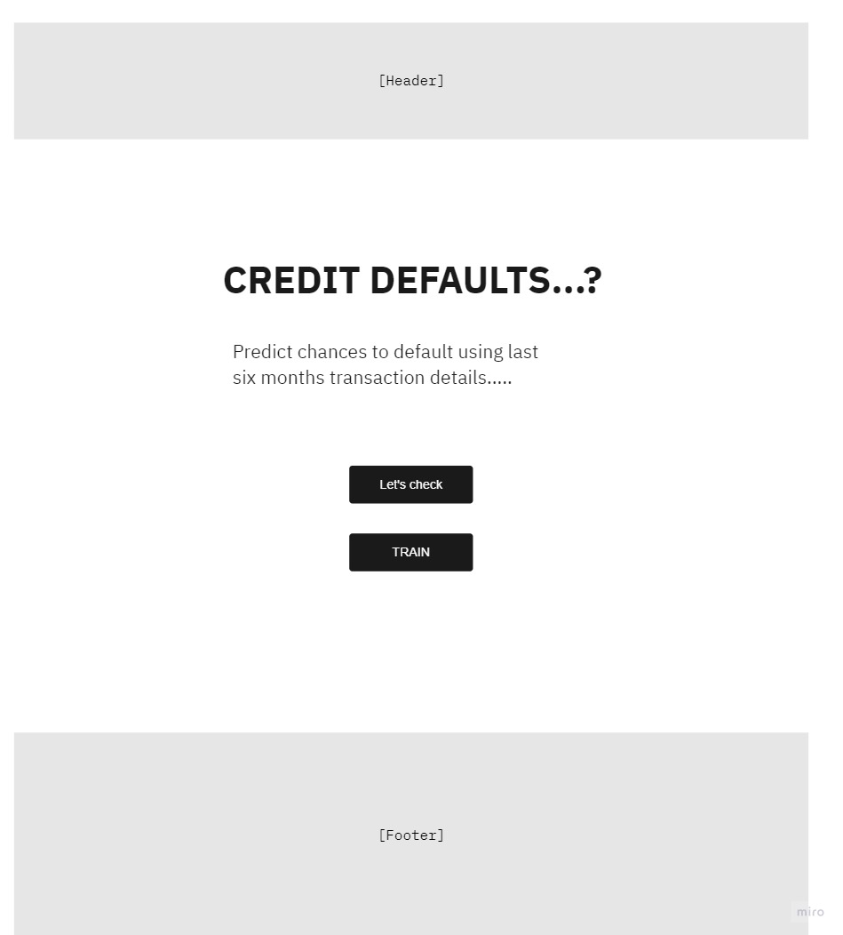

Fig-1 : Example Homepage

Predict page

This page we divided the box into grids, in each grid we have label of what data to input and the textbox to input the data.

One button also there on click which start the prediction.

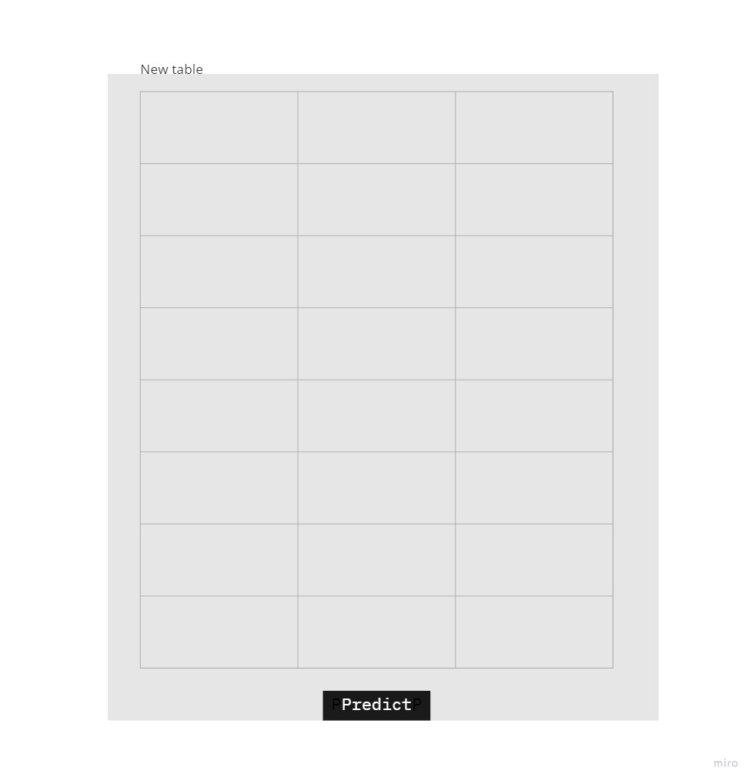

Fig-2 : Example Result Table

**RULES:**

1. Web Interface

1.1 Landing Page

1.2 Result Page

1. Web Interface

1.1 Landing Page

When the User land on our webpage, he/she sees a webpage welcoming them to Credit Card Default Prediction and ask them to move further by clicking on the ‘Predict!’ button.

[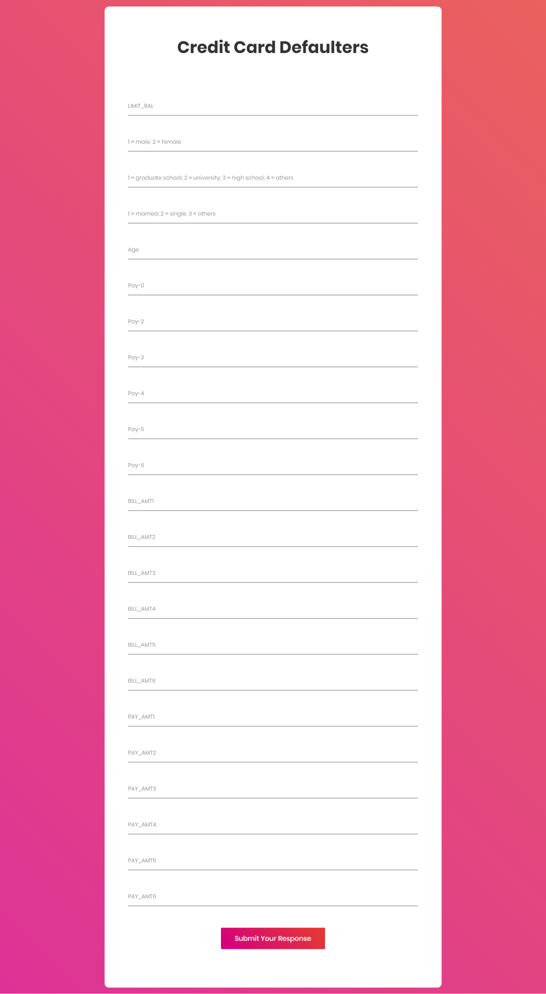](https://user-images.githubusercontent.com/89390696/175038923-c8a465d1-2aaa-4bc8-bb01-f6144e1c9c52.png)

**Result Page**

This is the next page that can be accessed by clicking on ‘Predict!’ button on the homepage or by clicking on predictor tab in the navigation bar on the homepage. The user sees various fields asking for information that is required to predict the Credit Card Default. Every user input has its own dropdown where the user can select their input. After providing the required input and pressing the submit button, the page refreshes and displays the predicted Credit Card Default.

[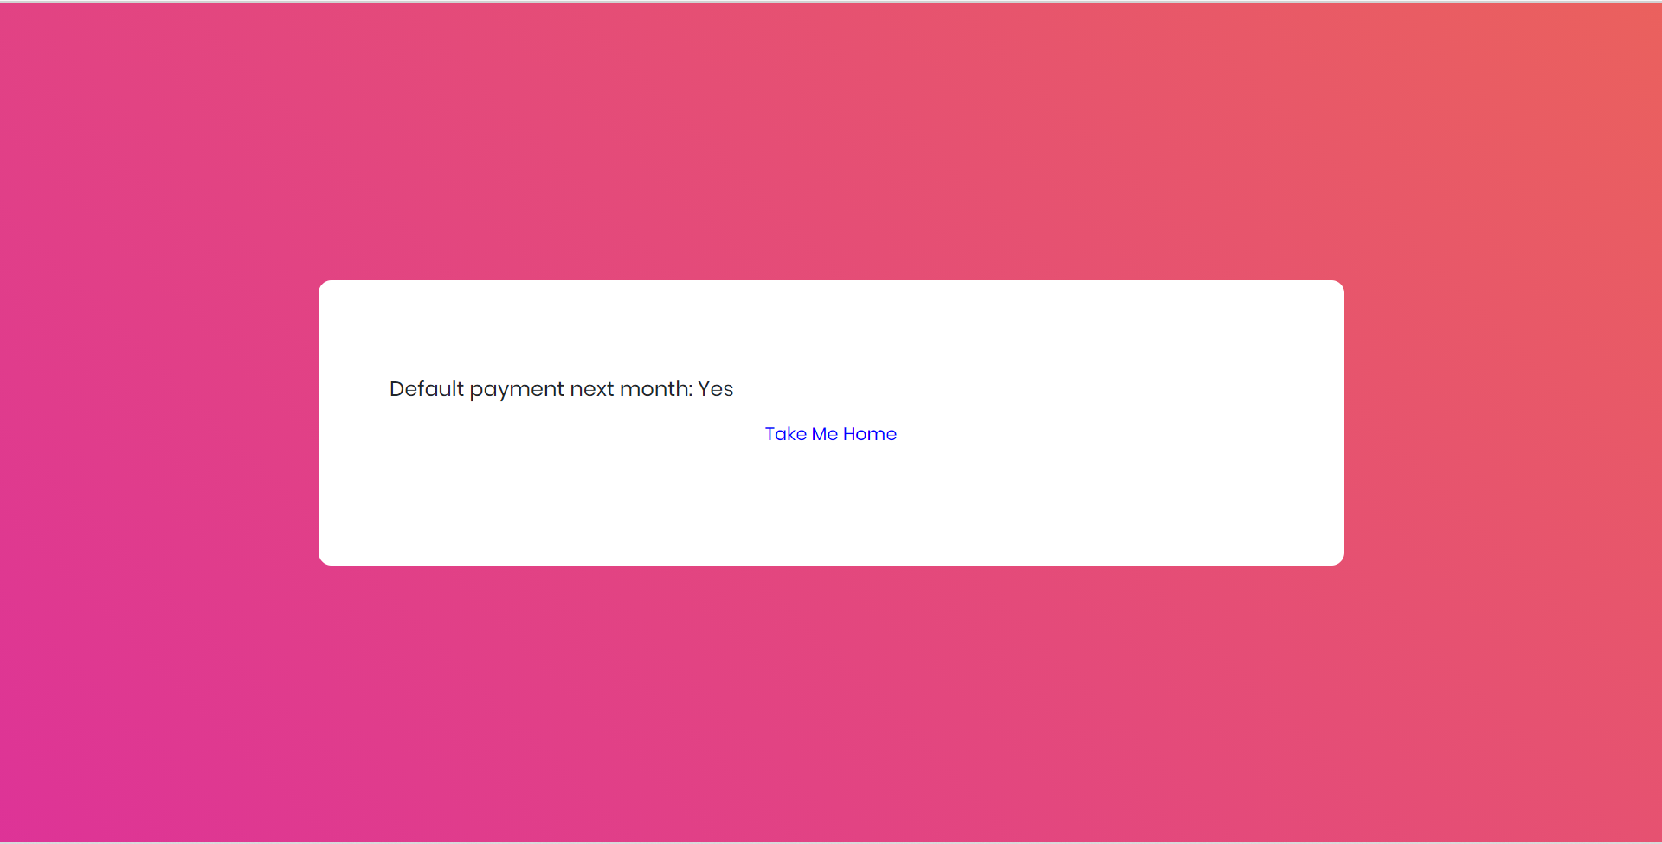](https://user-images.githubusercontent.com/89390696/175039566-0edf7041-dccf-4238-86d4-38169c611454.png)